Power Shell 101
Module 1B – PowerShell in VSCode
3/2/2019 Developed by Sam Chung
Center for Information Assurance (CIAE) @City University of Seattle (CityU)

Learning Outcomes
- Learn how to install the PowerShell extension in VSCode

Resources
- PowerShell in Visual Studio Code, https://code.visualstudio.com/docs/languages/powershell

Activities
- Installing
- Testing
- Q&A

Installing
- Open your VSCode.
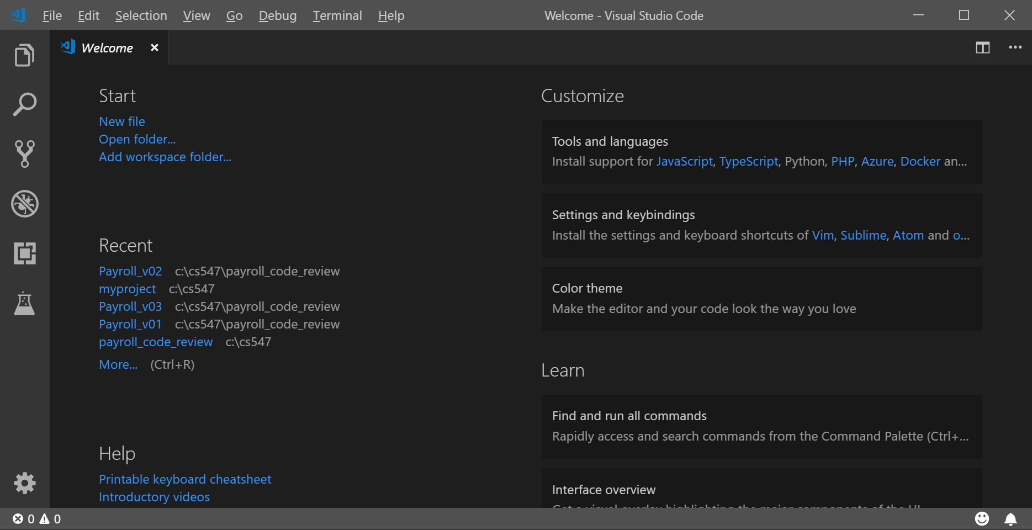
- Open the Extensions view with keyboard shortcut “Ctrl+Shift+X” and typing “PowerShell” and select the PowerShell extension.
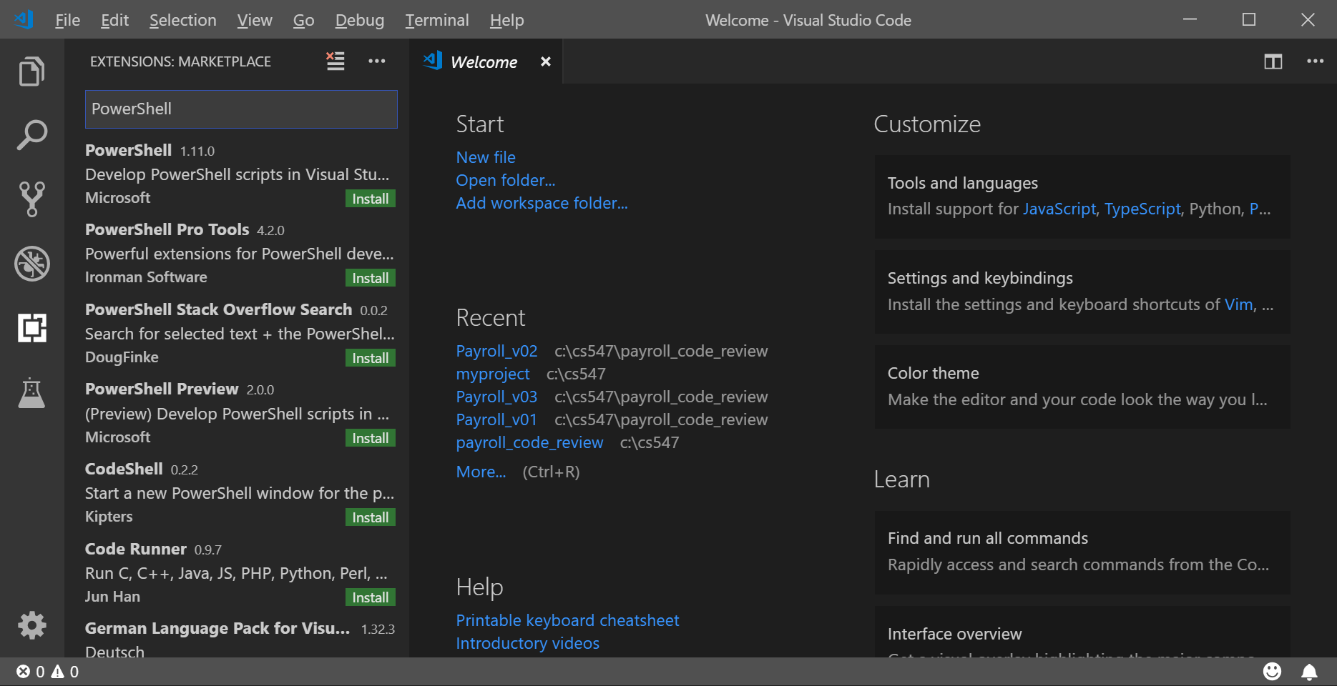

- Install “PowerShell”
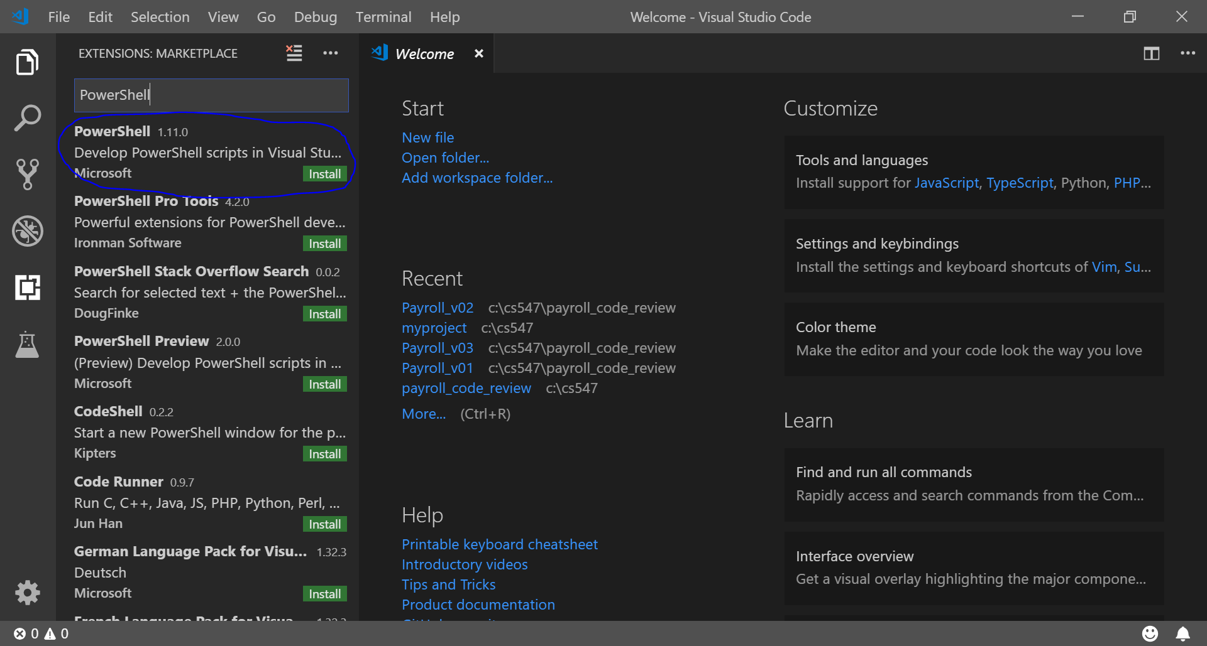
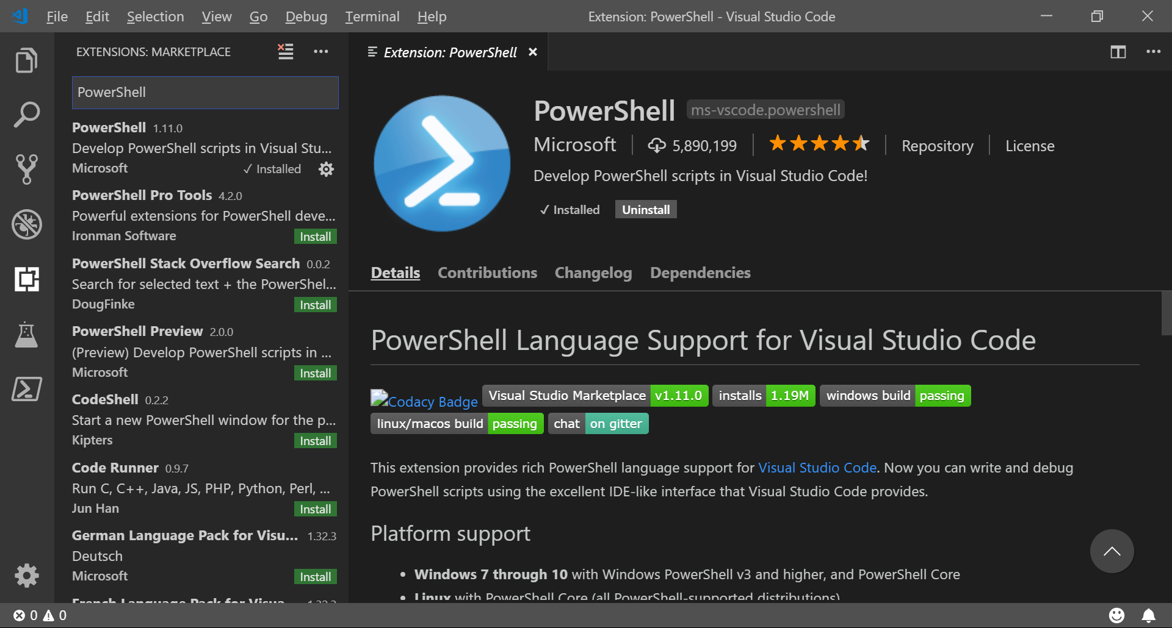
Testing
- To determine what version of PowerShell you have, type “$PSVersionTable.PSVersion”
You can see a little table with four columns: Major, Minor, Build, and Revision.
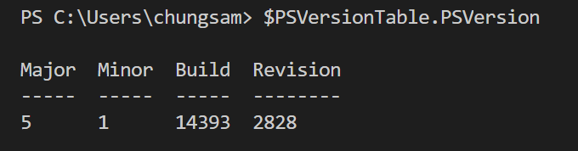

- When you forget PowerShell syntax or want to learn how a command work, if you type “Show-Command command” you can see that a GUI dialog box will be opened to help you complete a command. For example, type “Show-Command Get-EventLog”
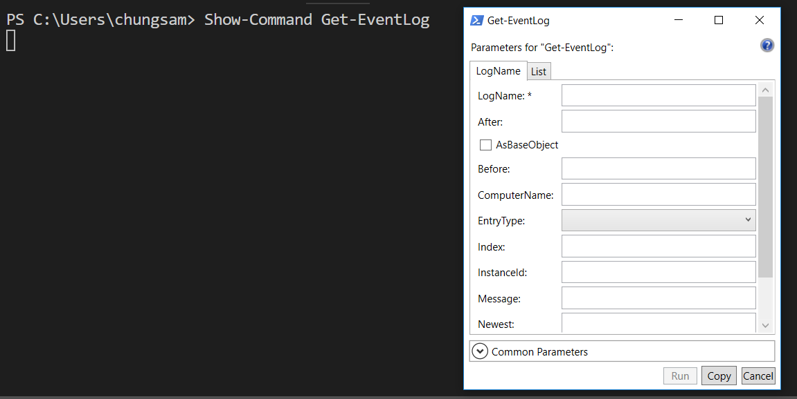

- To know your current directory, type “Get-Location”
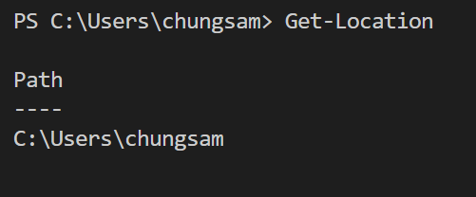

- To know your current directory, type “get-location” and “gl”
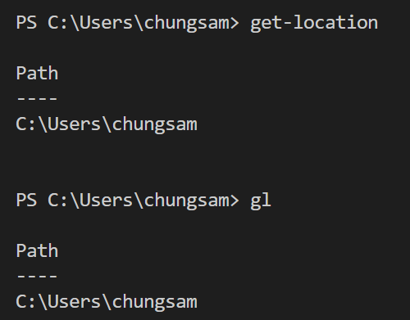

Q&A
Justify your answers with at least one reference.
- What is PowerShell?
The PowerShell is a command-line shell based on the .NET framework and designed for system administrators to use. Since Windows PowerShell build on top of .NET, it can accept and return objects. The PowerShell also includes an interactive prompt and a scripting environment.

https://docs.microsoft.com/en-us/powershell/scripting/getting-started/getting-started-with-windows-powershell?view=powershell-7

- Why do you need to learn PowerShell

One of the main reasons to learn PowerShell is because most Microsoft products will eventually use it. For example through PowerShell, we can manage virtually all server products from Microsoft. Also, it is a powerful tool for performing complex tasks for active directories. We can also manage domains if domain controllers running Windows Server 2003 with service pack 2 or higher.

https://www.techrepublic.com/blog/10-things/10-reasons-why-you-should-learn-to-use-powershell/

